**EXTERNAL RELATIONS**

**For the Media**

Welcome to the newsroom for the UT Dallas Naveen Jindal School of Management. Our external relations team is available to connect journalists with the Jindal School thought leaders and faculty experts. We can also provide information about our programs, research, and events.

There are many marketing resources here, including fast facts, our faculty expert list, press releases, and photos and images, but for immediate assistance, please contact the Jindal Schools’ Marketing Manager, Madi Franquiz, at madison.franquiz@utdallas.edu.

**Reasearch Excellence**

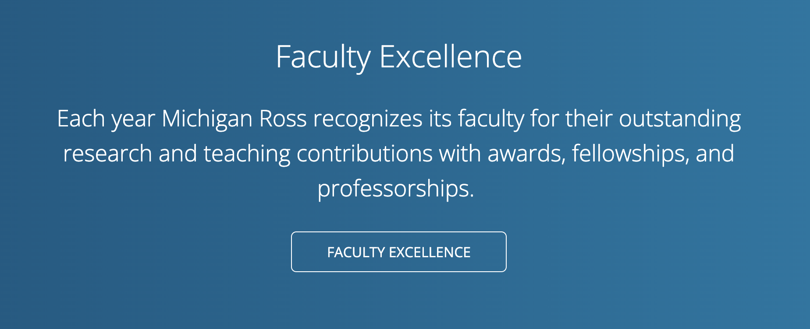*Button links to* [*https://jindal.utdallas.edu/research-ventures/*](https://jindal.utdallas.edu/research-ventures/)

Every year, Jindal School faculty members make remarkable contributions to research and teaching, elevating business initiatives and driving advancements in the management field.



**Faculty Experts**

The Jindal School is home to many globally recognized thought leaders who put their ideas into action. Jindal School faculty and staff are available to speak with reporters and share their unique insights, research, and expertise on almost every business-related topic, including entrepreneurship, healthcare, positive leadership, supply chain management, organizational culture, technology, and social impact.

*Button Link to Jindal School Faculty List* [*https://jindal.utdallas.edu/faculty/*](https://jindal.utdallas.edu/faculty/)

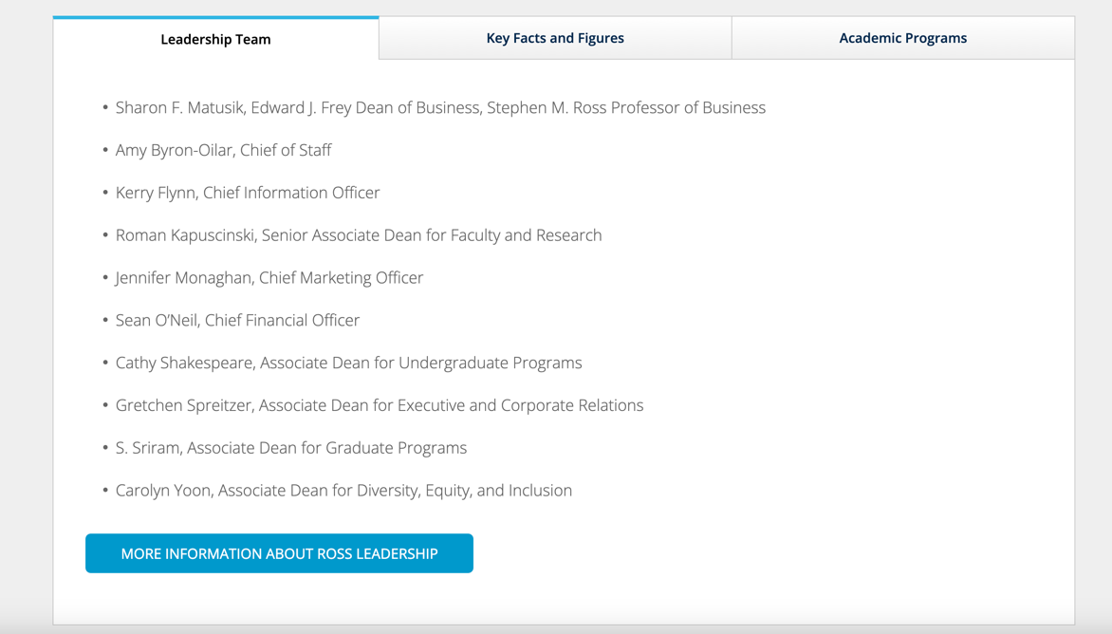

**Academic Leadership Team**

* Hasan Pirkul, Caruth Chair and Dean of the Jindal School of Management
* Varghese Jacobs
* Mark Thouin
* Guarav Sarkar
* Dawn Owens

**Key Facts & Figures**

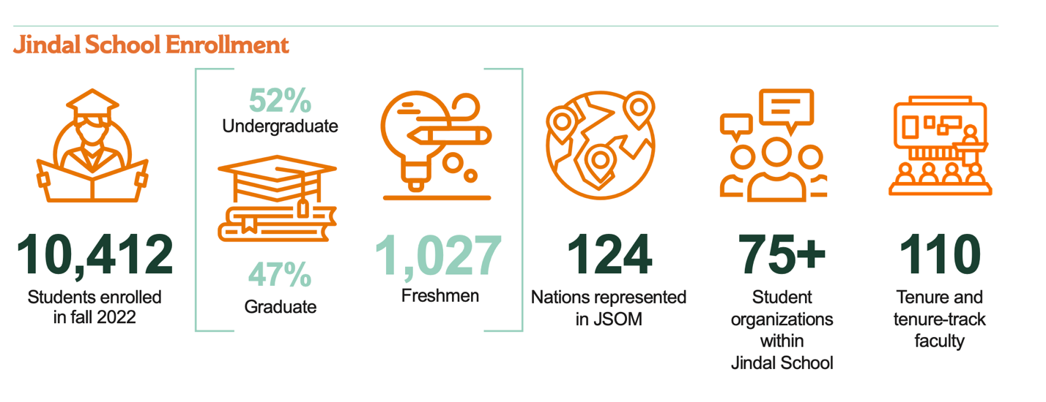**Add significant rankings here that D wants featured; also include VA rankings**

**Academic Programs**

The Jindal School of Management keeps abreast of corporate, and industry needs as an essential component in providing students with rigorous training and relevant skills for professional success. Programs are offered at the bachelor’s, master’s, PhD and Executive levels. Programs focus on six areas of business specialization:

* [**Accounting**](https://accounting.utdallas.edu/)
* [**Finance and Managerial Economics**](https://fin.utdallas.edu/)
* [**Information Systems**](https://infosystems.utdallas.edu/)
* [**Marketing**](https://marketing.utdallas.edu/)
* [**Operations Management**](https://om.utdallas.edu/)
* [**Organizations, Strategy and International Management**](https://osim.utdallas.edu/)

**{{Inside Jindal}}**



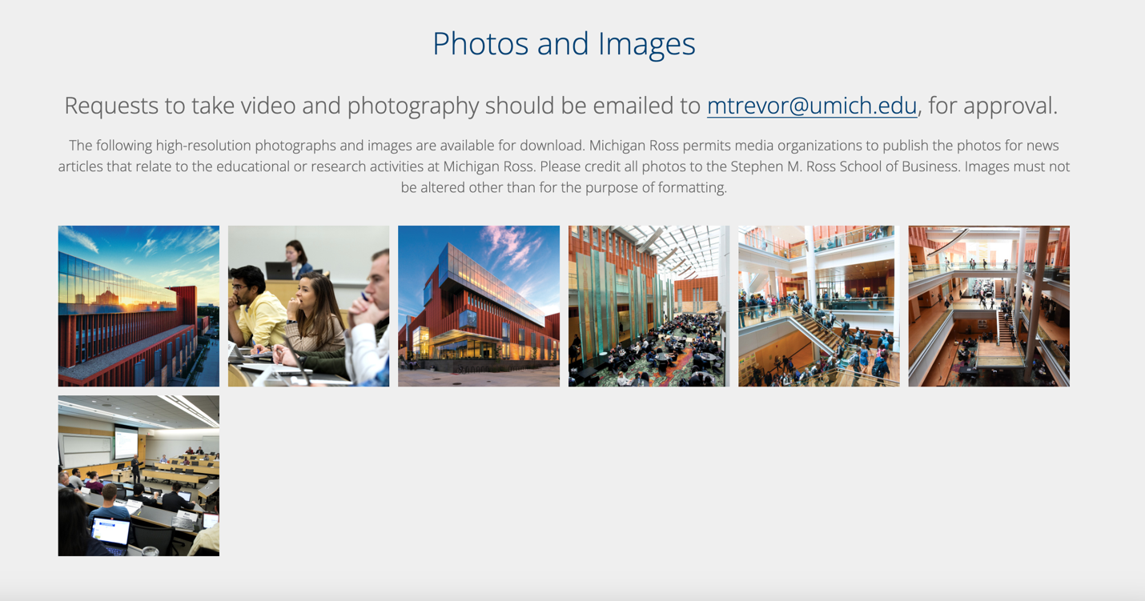

**{{Social Media}}**